Complaint against PV to Ombudsman

1) PV have misled the Minister for Energy, Environment and Climate Change about the need for the Set-aside determinations and the related Closures that it announced in February 2019. These closures prohibited climbing from vast areas of the Grampians National Park.
PV attempted to justify its actions in two Ministerial Briefing papers it sent to the Minister (both signed by PV CEO, Matthew Jackson, the first on 1st March 2019 and the second on 19th March 2019). These justifications were based on incorrect and unjustifiable statistics, numerous instances of false attribution of harm, and various distortions and exaggerations of the truth that were, at the very least, negligent and disingenuous and seemingly designed to mislead the Minister.
See Appendix 1

2) PV’s lack of genuine consultation.
Whilst Parks Victoria (PV) has been quick to suggest it has involved climbers in numerous community “engagement forums” and climbing roundtable” meetings, the reality is that these have been “inform only” meetings, not genuine consultation. It is telling that Parks Victoria’s Engagement and Communications Plan for Rock Climbing in the Grampians (prepared in February 2019), obtained under Freedom of Information Act 2018, indicates clearly that PV has only committed to work with all stakeholder groups, including rock-climbers, to inform. There is no commitment to consult let alone involve or collaborate.

What makes this worse is that these inform sessions are virtually always ‘after the event’ – after PV have made decisions and initiated actions, then gone through the charade of consultation.
See Appendix 2

3) PV have breached the Public Administration Act 2004 codes of conduct.
Climbers have grounds to believe that they have been unfairly used as scapegoats for actions of the general public. These grounds include Park Victoria’s false attributions of damage documented in Appendix 1 and the manifestly false statistics and misleading claims made by PV executives to the Minister [Impartiality (i) making decisions and providing advice on merit and without bias, caprice, favouritism or self-interest, Public Administration Act 2004. Impartiality (ii) acting fairly by objectively considering all relevant facts and fair criteria, Public Administration Act 2004].
The belief by climbers that they are being discriminated against is further buttressed by the fact that the Set-aside Determination prohibits climbing in vast areas of the Grampians but does not preclude other park visitors such as hikers or general tourists (whose very presence has an impact on the cultural heritage and environmental of the Park) from continuing to visit those same areas. The Set-Aside Determination does not prevent other visitors or other activities which have caused damage in the past from continuing to cause damage at sites where climbing is now proscribed [Impartiality (iii) implementing Government policies and programs equitably, Public Administration Act 2004].
PV’s actions have not exhibited the impartiality required by the code of conduct for public servants – it has been discriminatory and unreasonably targeted at climbers.
See Appendix 3

4) PV’s failure to follow the afore-mentioned processes, in announcing and implementing closures of over 550 sq km of the Grampians National Park to climbers, from February 2019 onward (and more recently adding more zones from which climbers are prohibited) has resulted in severe economic hardship for many businesses and individuals who depended to a significant degree from climbing tourism for their financial viability and wellbeing.
See Appendix 4

Appendix 1 – Parks Victoria’s false and misleading information in two Ministerial briefing papers
In February 2019, Parks Victoria (PV) announced it had made a Set-aside Determination that prohibited climbing in a huge section of Gariwerd / the Grampians National Park.
Over the next two months, PV endeavoured to justify the rationale for the prohibition in two ‘after-the-fact’ ministerial briefing papers, sent to the Minister for Energy, Environment and Climate Change, Lily D’Ambrosio.
The following is a compilation of a litany of factual errors, distortions, unjustified (and unjustifiable) assertions and false attributions that PV included in the aforementioned ministerial briefing papers.

Misleading information in Ministerial Briefing Report MBR038732 (signed by PV CEO Matthew Jackson on 1 March, 2019)
In the key information section of the briefing report,
Point 2 notes “…the number of climbing sites within the Grampians National Park have risen exponentially in recent years – from approximately 2,000 sites in 2003 to an estimated 8,000 sites in 2018. This has been accompanied by an increase in annual rock climbing visitations from an estimated 8,000 people in 2003 to 80,000 people in 2018.”
Parks Victoria’s figures are based, by their own admission, on one online geo-wiki ‘theCrag’ www.thecrag.com (see Ministerial Briefing Report MBR038945 – key information point 6). Parks Victoria mistakenly assumed that the date when a climbing route was first established corresponded to the date when the route was first entered onto theCrag.
Most routes established between 1960 and 2000 weren’t entered onto that database until the mid-2000s. Collation of data from a raft of rock climbing guidebooks to the Grampians indicates that there were in the order of 7,000 climbs already established by the year 2000. Climbing development has been steady across the decades, with a slight surge during the 1990s. Parks Victoria’s claim that development has been “exponential in recent years” is not merely unsubstantiated, it is demonstrably false.
The figures quoted for rock climbing visitations “from an estimated 8,000 people in 2003 to 80,000 in 2018” is similarly flawed. As the internet has become more popular, the number of climbers logging their ascents on theCrag has inevitably increased. This increase does not correlate to any increase in climbing visits to the Grampians. Nor does the number of different climbs logged by an individual climber on any particular day correspond to the number of visits made to the Park. Other measures of the popularity of climbing in the Park (such as climbing guidebook sales) indicate a far more modest increase in climber visitations for the period 2003 – 2018 (in the order of 20%) than the 10-fold increase suggested by Parks Victoria.
Point 3 notes “In addition to the increase in visitation, the nature of rock climbing activities has evolved to include the increased use of fixed protection (such as permanent climbing bolts and climbing/abseil anchors) as well as the introduction of a newer climbing activity known as bouldering.”
The reference to fixed protection implies that this is a recent phenomenon. In fact, the use of fixed protection was developed approximately 100 years ago. In the 1970s an attitude evolved among the climbing community worldwide (in keeping with the environmental awareness of the times) that resulted in a move away from unnecessary fixed protection and an increase in the use of re-usable/removable forms of protection that left no trace on the rock. It is true that small protection bolts are still used on some climbs (typically the bolt head protruding from the rock is the size of the tip of one’s little finger and usually very hard to discern from the ground), but only on those routes lacking features that could be used for natural protection or on routes that are severely overhung. Such climbs naturally tend to be devoid of lichen or other vegetation. Abseil anchors are generally only fixed when abseil descent is used to avoid the risk of erosion that might occur if climbers had to scramble down from the tops of climbs via steep gullies.
In other words, use of fixed protection is not new, is typically limited to sections of cliff where there is no vegetation to damage, and is often (in the case of descent anchors) used to mitigate potential environmental impact.
Point 4 notes “Bouldering … requires protective mats to be placed below the climber which leads to significant damage to and loss of vegetation.”
Contrary to the suggestion in point 3 that bouldering is a “newer climbing activity”, climbers have been bouldering in the Grampians for well over 50 years.
Not all boulderers use mats and not all those who use mats use them all the time. Mats are more likely to be used when the base below the boulder is a rock platform or is strewn with rocks that might cause injury to the person bouldering in the event of a fall.
Ground compaction and impact on vegetation is possible, as it is with any off-track walking, but it is not inevitable. The use by Parks Victoria of the words “which leads” (with its implication of inevitability) rather than “which can lead” gives the wrong impression.
Point 5 notes “The increased popularity of rock climbing has also led to the establishment of informal bush camps and networks of walking tracks as climbers seek to access more remote parts of the Grampians National Park.”
Climbers have not “established” any camps. They have partaken of dispersed/bush camping, as they are allowed to do in the National Park with the usual caveats (“campfires not permitted / fuel stoves only; only bush camp in previously cleared areas; leave no trace of your visit / take all rubbish home with you; camp at least 25m from waterways and 1km from campgrounds” and not within particular designated areas) as per the Grampians National Park Visitors Guide, downloadable from Parks Victoria’s website.
Most of the walking access to crags is along established tracks for most of the approach. Generally, the off-track component is short. Where cliffs aren’t that popular, walking through the bush leaves minimal trace. Where cliffs are very popular, climbers have traditionally worked with Parks Victoria (through organisations such as the VCC’s environmental arm, CliffCare) to ensure appropriate tracks are built. These tracks avoid environmentally sensitive areas or places of significant cultural heritage and are constructed to minimise the potential for erosion. Climbers have supplied volunteers to work under Parks Victoria direction in carrying out many such micro-infrastructural projects over the last two decades.
Point 6 notes “This [the issues raised in points 1 to 5] has significant implications for the Park’s environmental and cultural values. To ensure that the environmental and cultural values of the Park are maintained, Parks Victoria needs to implement Special Protection Areas (SPAs) across the Grampians that will exclude some areas from climbing activities.”
SPAs are described and defined in the 2003 Grampians Management Plan. Parks Victoria has not only ignored the proscribing of climbing in SPAs as outlined in the 2003 plan, but has actively collaborated with climbers in the realigning of tracks to cliffs in these SPAs and the hardening of staging areas at the foot of popular climbs. It has even worked with climbers and Traditional Owners to ensure protection of cultural sites at cliffs popular with climbers. Presumably, Parks Victoria staff and management would not have done so if they had believed that climbing was not a minimal impact activity.
Point 11 notes “Over a number of years, the scale of climbing activity has significantly increased and the nature of the activities has changed. In combination, these factors have caused significant impacts to irreplaceable cultural and environmental assets, as well as increasing risks around visitor safety.”
See the comments pertaining to points 2 and 3 regarding incorrect climber numbers. Claims for significant deleterious impacts due to changes in how people climb safely are also hugely overstated; they are based on misunderstandings of how climbing “works”, as well as numerous unsubstantiated false attributions to climbers of instances of harm at sites co-frequented by non-climbers and non-climbing groups.
Parks Victoria has traditionally worked with walkers, climbers, 4WD enthusiasts, fisher-folk and other recreational groups. When there is the potential for the environmental impacts of such groups to become pronounced, because of the sheer weight of numbers enjoying their recreation in the Park, Parks Victoria has traditionally pre-empted such impacts by working with groups to come up with mutually beneficial solutions.
It is therefore disappointing and disingenuous of Parks Victoria to manufacture statistics as a basis for claims of an explosion in the popularity of a pastime, to misrepresent how that pastime “works”, and to falsely attribute instances of harm to participants of the pastime in question without evidence to substantiate these attributions, all seemingly to justify poorly framed ‘solutions’ to the perceived problems.

Misleading information in Ministerial Briefing Report MBR038945 (signed by PV CEO Matthew Jackson on 19th March 2019)
In the key information section of this report, under the subheading Impacts of Rock Climbing on the Park (points 20 – 23), some of the false claims made in Ministerial Briefing Report MBR038732 are repeated (see above).
Point 22, referring to bouldering, notes that “protective mats to be placed below the climber … leads to significant damage and loss of vegetation” and refers to eight photos in an attachment to the report.
The first four of these photos are of ground at the base of, or adjacent to, boulders along the track to Venus Baths area. The short flat walk to Venus Baths from the tourist epicentre Halls Gap is possibly the most popular walking track in the whole of the Grampians. The amount of litter, including tissues left by tourists seeking a discreet place behind boulders near the track where they can urinate unseen, has to be seen to be believed. To attribute areas of ground compaction or trampling of vegetation to climbers simply because they co-frequent these areas is disingenuous.
- 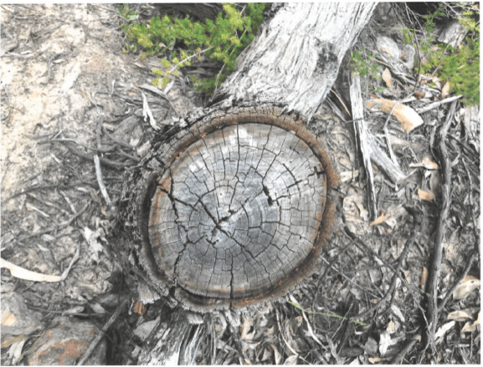The tree stump at Millenium Cave area
- 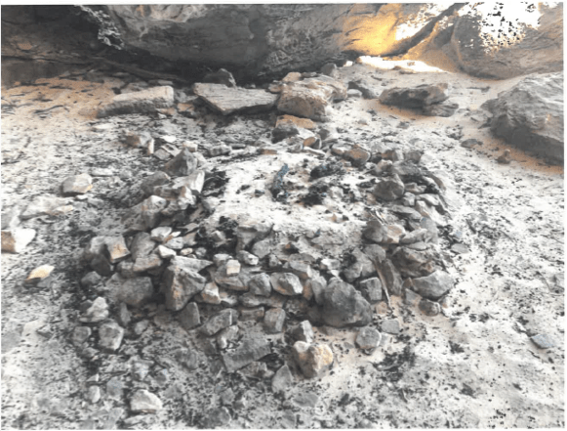The ring of stones at Millenium Cave area
The fifth, sixth and seventh photos are all taken at the Millenium Cave area. They are of a makeshift ring of stones (fireplace – see above) under the overhanging cliff serving as a shelter from the weather, a tree stump seemingly clean-sawn (see above), and some small piles of stacked stones. Millenium Cave is a site co-frequented by walkers, general tourists and climbers. I have personally witnessed large school groups camping there. For Parks Victoria to automatically assume that climbers have made and used the makeshift fireplaces or sawn a tree, or stacked the stones, at sites where climbers among others happen to frequent, is illogical and unprofessional.
The final photo, taken at a cliff in the Victoria Range called The Gallery, shows a chalk-marked sector of cliff. Gymnasts chalk is commonly used by climbers and normally washes off after rain. In four cliffs of the 600-plus climbing sites in the Grampians where a severely overhanging rock face happens to coincide with a predominantly bright, ochre-coloured rock (not the usual grey rock that is more characteristic of the Grampians) chalk residue on popular routes can be far more visible and, because of the fact that rain does not reach under the steep overhangs, is not readily washed away.
Chalk on overhanging sections of rock can be noticeable but does not affect the rock nor does it have any significant impact on vegetation – on steeply overhanging rock faces, not even lichen grows. The implied impact of the use of chalk by climbers in the Grampians is hugely overstated. Subsequent communications by Parks Victoria give a clue to its misunderstandings on this issue, and show its inability to discern the difference between chalk, the huge, naturally occurring white streaks in the rock, and the white discolouration caused by raptor guano (see https://savegrampiansclimbing.org/2020/06/17/expert-advice-chalk-or-nature/).
Whilst the Ministerial Briefing Papers referred to above are nearly a year-and-a-half old, ongoing communications and assertions by Parks Victoria during the intervening time, such as those referred to in relation to ‘chalk wash’, indicate that most PV executives still do not really get how climbing ‘works’.
It is also apparent that PV seems to have a huge blind spot about damage done by casual tourists walking to and across cultural heritage. For example, walking along a PV-made track up to Hollow Mountain, across rock that has been quarried by indigenous Australians, is allowed. However, climbing within a few hundred metres of that cultural heritage is not.

As far as we are aware, PV has still not sought to disabuse the Minister of the misleading information that its executives had presented to her – even after many of their errors and inconsistencies had been pointed out to them.

Appendix 2 – Parks Victoria’s failure to genuinely consult
Part A: Parks Victoria’s commitment to inform, not to consult
Whilst Parks Victoria (PV) has been quick to suggest it has involved climbers in numerous community “engagement forums” and climbing roundtable” meetings, the reality is that these have been “inform only” meetings, not genuine consultation. It is telling that Parks Victoria’s Engagement and Communications Plan for Rock Climbing in the Grampians (prepared in February 2019), obtained under Freedom of Information Act 2018, indicates clearly that PV has only committed to work with all stakeholder groups, including rock-climbers, to inform. There is no commitment to consult let alone involve or collaborate.

What makes this worse is that these inform sessions are virtually always ‘after the event’ – after PV have made decisions and initiated actions.

From Parks Victoria’s Engagement and Communications Plan for Rock Climbing in the Grampians :
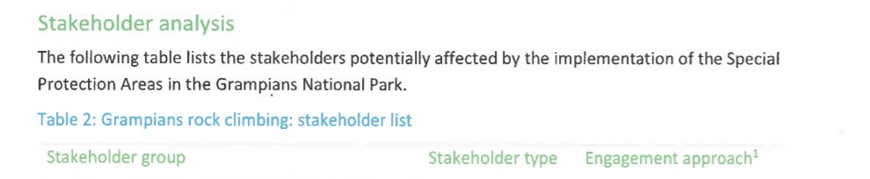

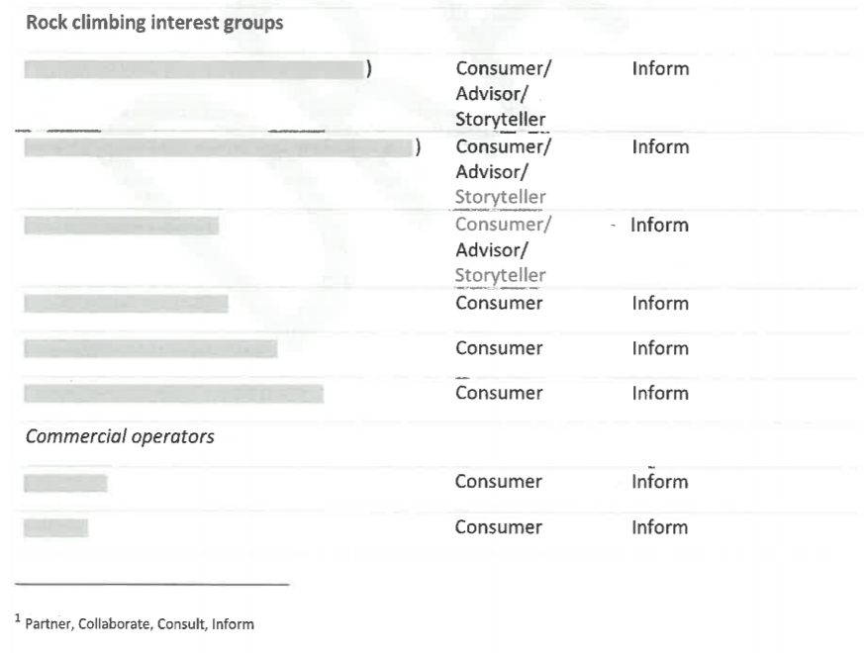

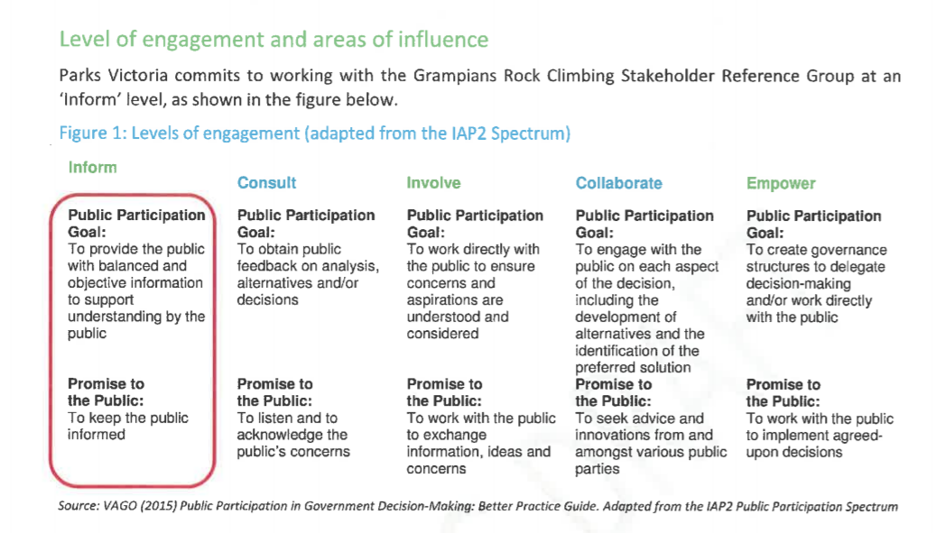

Climbers have engaged with Parks Victoria via all avenues available to them and have offered their considerable expertise to help develop a better mutual understanding of what climbing entails, how it might impact the environment, how such impacts might be easily mitigated, and what alternatives to huge exclusion zones would achieve better cultural and environmental protection. These offers have largely fallen on deaf ears. Climbers have offered to walk with PV staff and Traditional Owners on Country in the Grampians at various climbing sites, but without uptake.
Parks Victoria, despite their “consultations” in various forums, are seemingly implacable in their resolve not to change from the course embodied in their proclamation of the Set-aside Determination in February 2019.
This has been borne out by every forum that climbers have attended with Parks since PV proclaimed a Set-Aside Determination in February 2019 that prohibited climbing from huge areas in the Grampians national Park. On the 5th March 2019, the VCC vice-president at the time, Philipp Hammes, wrote to PV CEO, Matthew Jackson, noting that
“…in the face of specific enquiries by VCC to Parks Victoria regarding potential upcoming closures, Parks Victoria did not consult with VCC regarding the 8 Closures.
“For the avoidance of doubt, nor was VCC permitted to make submissions on the closures, nor were the gist of these closures made known to VCC prior to them being announced.
“Subsequent enquiries by VCC to Parks Victoria regarding the 8 Closures (and how they will operate have not been responded to properly (or at all).
“Since that time, the 29 Closures have also been announced, again with no notice, prior information or consultation with VCC”.
Nothing has changed in the intervening time (over a year and a half) since the original announcement of areas being closed to climbers. PV continues to inform after they have already made decisions and taken actions, rather than consult. Whilst PV has listened politely to climber concerns and climber suggestions for better ways to manage climbing that would meet PV’s legislative requirements to protect the environment and cultural heritage without huge exclusion zones, not a single suggestion from recreational climbers has been seriously looked at, let alone adopted by Parks Victoria.

Part B: The nexus between supposed consultation on the 2019 Set-aside Determination (and consequent Closures) and the Greater Grampians Landscape Management Plan
It is noteworthy that:
1) notwithstanding Parks Victoria’s clear plan and directives to inform, not consult with Rock climbers, PV insists in using the term “consult” to label and characterise their engagements with stakeholders, including at various so-called “consultation events” – see references to “Twelve consultation events” in the Consultation Summary Report, Greater Gariwerd (Grampians) Landscape Management Plan (March 2020)
2) in the more than 1 ½ years since the Set-aside determination was announced (February 2019) not a single constructive suggestion that has been put forward by the climbing community regarding alternative options to the Closures of climbing sites (across an area of over 550 square kilometres) has been adopted, or seemingly even considered by PV
3) PV has made it clear that it doesn’t intend to make any changes until the Greater Grampians Landscape Management Plan (GGLMP) process has run its course. This is despite the fact that even when this has happened (very optimistically, by the end of 2020) they will not have been able to carry out assessments on anywhere near all of the estimated 600-plus cliff sectors, isolated buttresses and bouldering areas across the Grampians.

As has been noted in correspondence from the VCC President to PV executives and to parliamentarians

‘To assess each site, PV needs to organise representatives for each
of the three Indigenous “mobs” to accompany PV staff and an accredited archaeologist to walk into the site and carry out the assessment. So far, in the last year and a half, they have carried out 125 site assessments—these have been sites that have been the “low hanging fruit” i.e. sites that have been relatively easy to access, mostly along good PV walking tracks. About half (62) of these sites are in the Mount Stapylton area and many of these sites are very close to each other, significantly expediting the assessment process. In contrast, many of the sites still to be assessed require significantly more difficult (physically more arduous) access. I would be astounded if these could all be done “in a coordinated and consistent manner” [Jason Borg, Parks Victoria] within 3 or 4 years.’ - Kevin Lindorff July 2020

4) In light of point 3), the argument that climbers are being consulted (about the changes that PV implemented in February 2019 without any prior notification) because they can have input into the Greater Grampians Landscape Management Plan (GGLMP) once the draft is completed and released for public consideration, is an argument for pretend consultation because:.
- The GGLMP will not provide detailed management approaches for the hundreds of different crags, cliff sectors, isolated buttresses and bouldering areas where climbing is currently prohibited.
- PV remains implacably opposed to allowing climbing in those areas that have been assessed and where no tangible cultural heritage has been identified and where there are deemed to be no significant risks to the environment from climbing. For those many, many sites that have not yet been assessed, it will take years for these assessments to be completed. The existence or not of a new GGLMP will not alter this fact.
- The GGLMP is not, cannot be and was never intended to be a detailed compendium of tailor-made management strategies for hundreds of different cliffs, cliff sectors and bouldering areas, depending on the individual site specifics. To argue then that climbers are being consulted about current and future prohibitions on climbing at hundreds of sites across the Grampians just because they can have input into the GGLMP is a fanciful piece of sophistry.

Appendix 3 – Parks Victoria’s failure to act fairly and impartially.
Park Victoria’s Set-aside Determination, announced in February 2019, and the initial 8 Closures and the subsequent 29 Closures later that year, apply to rock climbers only. These closures do not preclude people from exploring the set-aside areas on foot.
While it is acknowledged that climbers have had some impact at some of the sites in question, in the vast majority of cases where walkers, climbers and general tourists co-frequent, there is no legitimate basis for attributing any harm to cultural heritage to climbers. Conversely, in the past, walkers and tourists have been responsible for numerous instances of graffiti, litter, or establishing camping fires under rock shelters. Their future transgressions are not precluded or mitigated in any way by the Determination. Therefore one can only wonder about the efficacy of this unevenly applied determination in relation to cultural heritage protection. The same is true of protection of ecological sensitivities in the Park.
We feel targeted by PV in that we can walk into all of the areas where climbing is prohibited (as other hikers and general tourists can) – we just can’t leave the ground and climb at these locations.
This is despite the facts that:
- All tangible cultural heritage is within the reach of the ground (and in reach of general tourists who can and do still visit the sites in question),
- At many of the sites where climbing is prohibited, PV has carried out assessments and found no tangible cultural heritage. PV have refused written requests from the climbing community, including the VCC, to rescind the bans on climbing at assessed sites where no cultural heritage has been found and where climbing doesn’t pose any particular or significant risk of causing harm to the environment
- PV have argued that climbers are still being kept out of areas that have not yet been assessed for damage to cultural heritage or environment as a “precautionary approach” (letter of 20th July from Mr Jason Borg, Regional Director, Western Region, Parks Victoria to Ms Vanessa Bleyer on behalf of Mr Kevin Lindorff), yet hikers and general tourists have not been excluded from these sites on the same basis.
We certainly feel that being a climber has attracted differential, unwarranted and inequitable treatment from Parks Victoria.

The actions of Parks Victoria would appear to contravene the Code of Conduct and Public Sector Values as per the Public Administration Act 2004.
Specifically, Parks Victoria has failed to act with Impartiality – “public officials should demonstrate impartiality by:
(i) making decisions and providing advice on merit and without bias, caprice, favouritism or self-interest; and
(ii) acting fairly by objectively considering all relevant facts and fair criteria; and
(iii) implementing Government policies and programs equitably” (Public Administration Act 2004)
Parks Victoria has also failed to show appropriate Respect – “public officials should demonstrate respect for colleagues, other public officials and members of the Victorian community by: (i) treating them fairly and objectively” (Public Administration Act 2004).

The impact of these climbing prohibitions on the climbing community has been substantial. Apart from the impact of these prohibitions on physical and mental well-being of climbers, which has been significant and demonstrable, there has been a severe economic/financial impact on many individual climbers and on businesses which rely, in part or completely, on climbing tourism in the Grampians.

Some of these economic and financial impacts are outlined in Appendix 4

Appendix 4 – Effects of Parks Victoria’s failure to follow appropriate decision-making processes on many businesses and individuals

The impact of the Closures and climbing exclusions in the Grampians National Park on local businesses is, and will continue to be, severe.
Feedback that The Victorian Climbing Club has received from businesses that rely on climbing tourism for some of their income (including The Happy Wanderer Holiday Resort at Wartook, The Grampians Edge Caravan Park at Dadswells Bridge and Mount Zero Log Cabins near Mt Zero) suggests that the climbing Closures and prohibitions have had a significant detrimental impact during the 2019 calendar year, with a decline in income of approximately 25 per cent compared to the year before).
Other businesses that rely more directly on climbing, including but not limited to guiding operations, climbing retail stores, climbing guidebook publishers and retailers, climbing media organisations, with hundreds of employees between them, have reported even greater declines (pre-COVID-19). There was no community consultation with such businesses prior to the Set-aside Determination and associated Closures in the Grampians.
The virtual shut-down of a number of rock-climbing guiding businesses that have substantial operations in the Grampians is certainly indicative of the profound impact that the climbing prohibitions currently in place at prime climbing areas in the Grampians. Again, it is important to reiterate that such shut-downs and slow-downs were well and truly apparent prior to Covid-19 wreaked further havoc on the regional (and national and international) economies.
More recently, climbing and bushwalking guidebook publisher Open Spaces Photography has informed its online followers that:
“There is no doubt that the massive Grampians climbing bans (on an unprecedented global scale and which have come into force over the last 18 months) combined with the recent Bundaleer and Taipan Wall climbing and bushwalking bans, have forced Open Spaces to re-evaluate our position. In these uncertain times and given the likelihood of further climbing and bushwalking bans in both the Grampians and at Mt Arapiles we have decided to cease all of our planned publications to these areas. A business like ours cannot be expected to operate where there is no certainty. We are especially disappointed that Parks Victoria and the Traditional Owners have decided not to engage with the climbing and bushwalking communities and instead continue to foster this uncertainty. Our own recent discussions with senior Parks Victoria staff regarding our forthcoming Grampians bushwalking guidebook have also given us further cause for concern.”
https://osp.com.au/?page_id=766
Other publishers including Sublime Climbs and Onsight Photography have put plans for future guidebook coverage of the Grampians on hold and are re-evaluating their positions.
The threat to the ongoing viability of climbing-related businesses in particular, and tourism businesses that cater in part to climbers, has been worsened by COVID-19. However, the information we are receiving is that even if the effects of COVID-19 on the local economy were to disappear in the near future, the ongoing loss of patronage due to fewer climber visitations will mean that some businesses are still likely to fold.

